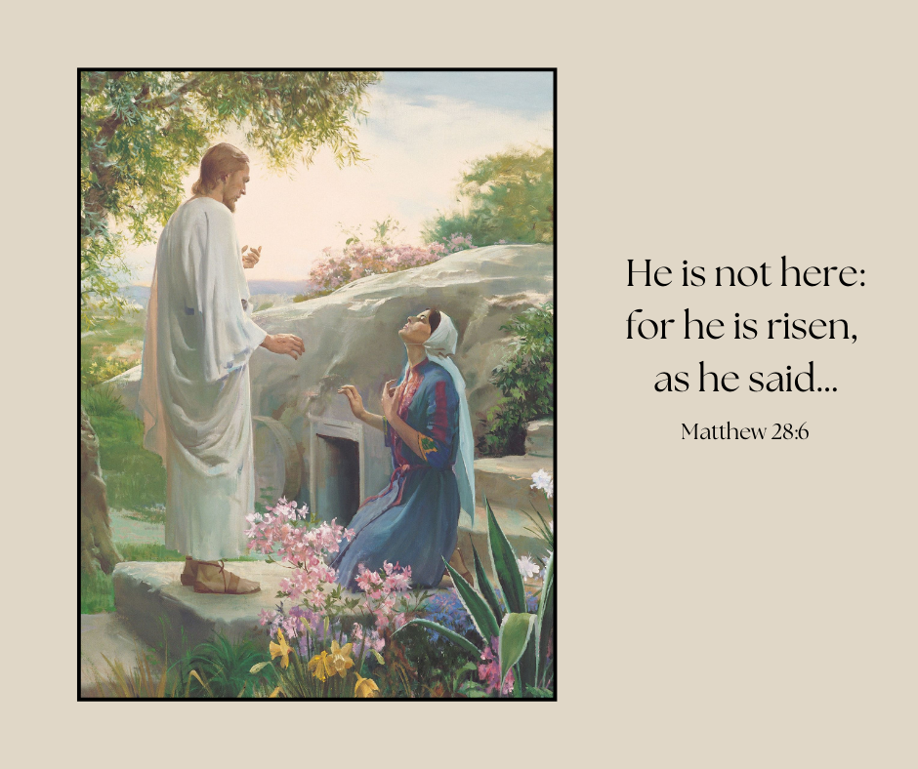

Picture available here: <https://www.churchofjesuschrist.org/media/image/mary-and-the-resurrected-christ-1728928?lang=eng&collectionId=3cbf78e787498a07417814a31656063f9227b4c6>