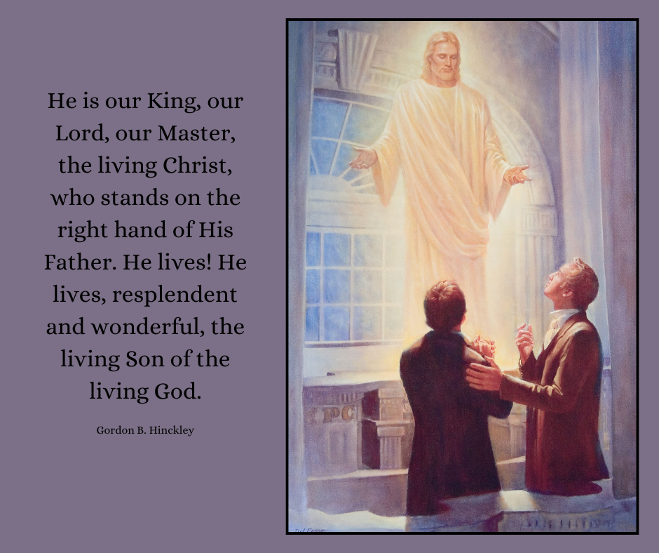

Picture available here: <https://www.churchofjesuschrist.org/media/image/christ-appearing-smith-cowdery-parson-92bb162?lang=eng&collectionId=3cbf78e787498a07417814a31656063f9227b4c6>