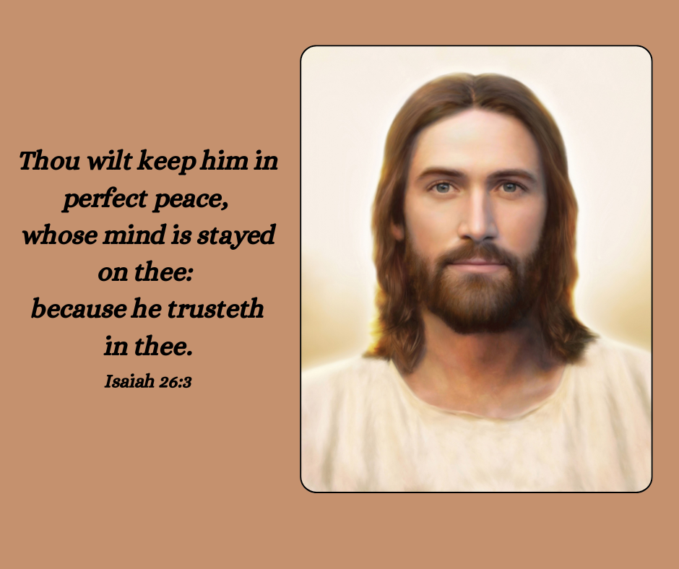

*Picture of Christ found here*: <https://www.churchofjesuschrist.org/media/image/light-of-the-world-jesus-christ-3cf7b89?lang=eng&collectionId=3cbf78e787498a07417814a31656063f9227b4c6>